**ETHICAL HACKING**

**EXPERIMENT 7 – GOOGLE AND WHOIS FOR RECONNAISANCE**

**INDHUMATHI V**

**192124215**

**OPEN WHO.IS WEBSITE**



**ENTER THE NAME OF DOMAIN**

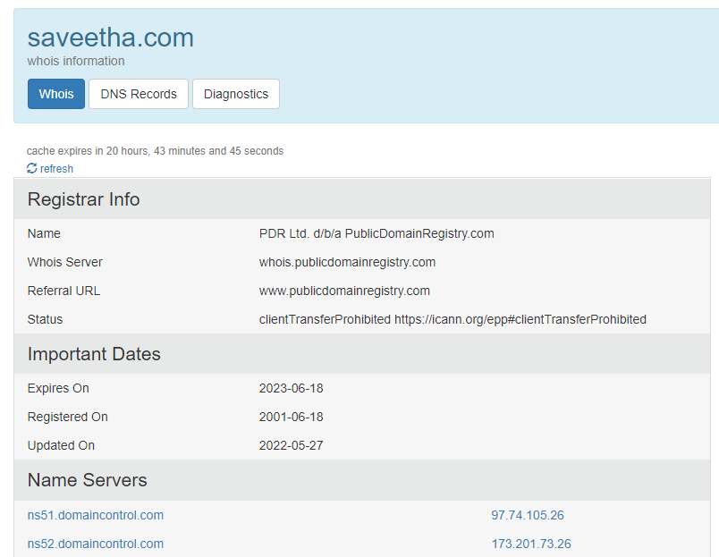

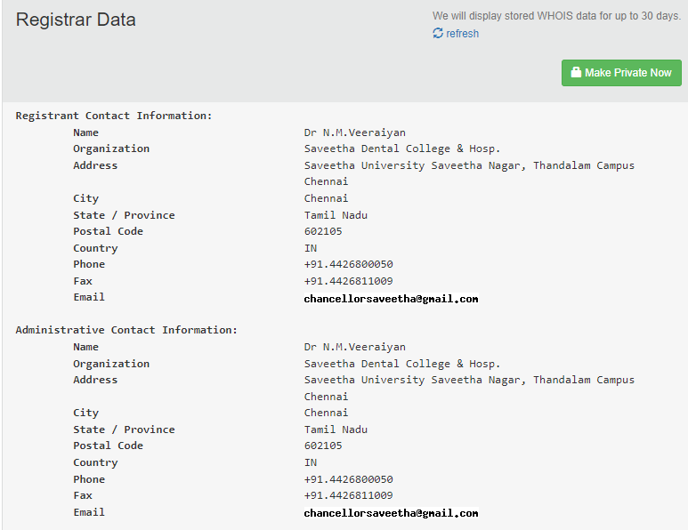

**DNS RECORDS**

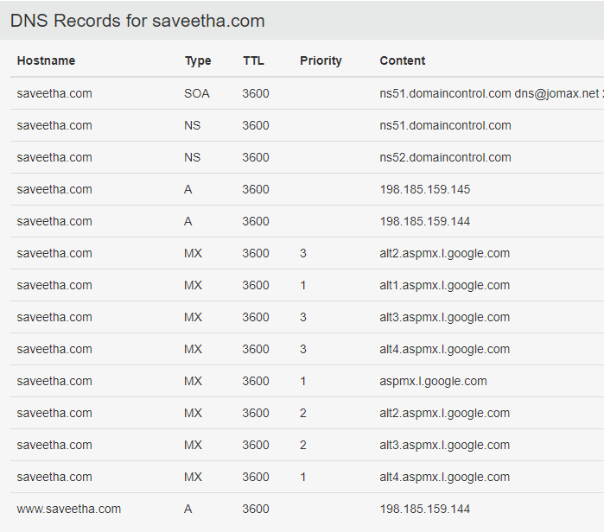

**DIAGNOSTICS**

